**ABOUT US**

**Mirage Group,** as the name suggests, is a company which provides prominent solution to all your realty investments. We are a real estate consulting company in Maharashtra with a vision to succeed on the principles of commitment, honesty and reliability. Driven by the same mission we thrive to get the best possible opportunity for both our investors who use real estate assets to increase their wealth as well as home seekers planning to make the biggest decision of their lives. Transparency in transactions and uniformity in contracts is our second name We have a forte in real estate advisory and we believe every buying experience should be a simple and successful accomplishment from a DREAM to REALITY. The driving force behind it is our team of real estate advisors who have a zest for fundamental values of customer satisfaction, credibility and professionalism.

Mirage Group is destined to have some of the finest professionals in real estate industry who have a niche in exploring property just as per your requirement. We at **MirageGroup** meticulously mentor our staff not only to find you a property but also use Real Estate as a tool to add to your assets. There is no denying the fact that buying a property in India is a cumbersome process as consumers require real time advice, property comparison, property tours, deal closure, legal and home loan assistance to make this major decision of their lives. Keeping this in view and to serve you well on each aspect, our diligent team of experts at **MirageGroup** spends countless man hours evaluating each and every project. The end product is that you are unchained from the hassles which an individual has to go through for investing in real estate. In addition to our personal service, **MirageGroup** offers comprehensive information of real estate opportunities and helps in securing loan at genuine interest rates. This is a clarion call to come and let us help you take the right decision on the real estate investment you make with our knowledgeable and market savvy consultants and make your DREAMS COME TO REALITY.

**TERMS OF SERVICE**

Welcome to Mirage Group

These terms and conditions outline the rules and regulations for the use of Mirage Group Website.

Mirage Group is located at:

Pradhikaran, Nigdi, pune 411033

By accessing this website we assume you accept these terms and conditions in full. Do not continue to use Mirage Group website if you do not accept all of the terms and conditions stated on this page.

Throughout the site, the terms “we”, “us” and “our” refer to Mirage Group. Mirage Group offers this website, including all information, tools and services available from this site to you, the user, conditioned upon your acceptance of all terms, conditions, policies and notices stated here.

By visiting our site and/ or purchasing something from us, you engage in our “Service” and agree to be bound by the following terms and conditions (“Terms of Service”, “Terms”), including those additional terms and conditions and policies referenced herein and/or available by hyperlink. These Terms of Service apply to all users of the site, including without limitation users who are browsers, vendors, customers, merchants, and/ or contributors of content.

Please read these Terms of Service carefully before accessing or using our website. By accessing or using any part of the site, you agree to be bound by these Terms of Service. If you do not agree to all the terms and conditions of this agreement, then you may not access the website or use any services. If these Terms of Service are considered an offer, acceptance is expressly limited to these Terms of Service.

Any new features or tools which are added to the current store shall also be subject to the Terms of Service. You can review the most current version of the Terms of Service at any time on this page. We reserve the right to update, change or replace any part of these Terms of Service by posting updates and/or changes to our website. It is your responsibility to check this page periodically for changes. Your continued use of or access to the website following the posting of any changes constitutes acceptance of those changes.

**ONLINE TERMS**

By agreeing to these Terms of Service, you represent that you are at least the age of majority in your state or province of residence, or that you are the age of majority in your state or province of residence and you have given us your consent to allow any of your minor dependents to use this site.

You must not transmit any worms or viruses or any code of a destructive nature.

A breach or violation of any of the Terms will result in an immediate termination of your Services.

**GENERAL CONDITIONS**

We reserve the right to refuse service to anyone for any reason at any time. You agree not to reproduce, duplicate, copy, sell, resell or exploit any portion of the Service, use of the Service, or access to the Service or any contact on the website through which the service is provided, without express written permission by us.

The headings used in this agreement are included for convenience only and will not limit or otherwise affect these Terms.

**ACCURACY, COMPLETENESS AND TIMELINESS OF INFORMATION**

The information is provided by Mirage Group and while we endeavour to keep the information up to date and correct, we are not responsible if information made available on this site is not accurate, complete or current. The material on this site is provided for general information only and should not be relied upon or used as the sole basis for making decisions without consulting primary, more accurate, more complete or timelier sources of information. Any reliance on the material on this site is at your own risk.

This site may contain certain historical information. Historical information, necessarily, is not current and is provided for your reference only. We reserve the right to modify the contents of this site at any time, but we have no obligation to update any information on our site. You agree that it is your responsibility to monitor changes to our site.

**INTELLECTUAL PROPERTY RIGHTS**

Unless expressly agreed to in writing, nothing contained herein shall give the User a right to use any of the Website’s trade names, trademarks, service marks, logos, domain names, information, questions, answers, solutions, reports and other distinctive brand features, save according to the provisions of these Terms. All logos, trademarks, brand names, service marks, domain names, including material, designs, and graphics created by and developed by the Website and other distinctive brand features of the Website are the property of the Company. Furthermore, with respect to the Website created by the Company, the Company shall be the exclusive owner of all the designs, graphics and the like, related to the Website.

The User may not use any of the intellectual property displayed on the Website in any manner that is likely to cause confusion among existing or prospective users of the Website, or that in any manner disparages or discredits the Company/Website, to be determined in the sole discretion of the Company.

The User is aware that the products displayed on the Website are the artistic creations of their respective owners, and that all intellectual property, including but not limited to copyrights, relating to said products resides with the said owners, and that at no point does any such intellectual property stand transferred from the aforementioned creators to the Website/Company, or to the User. The User is aware that the Company merely provides a platform through which the aforementioned products are listed for sale to the users of the Website, and the neither the Company nor the Website owns any of the intellectual property relating to the products displayed on the Website.

The User is further aware that any reproduction or infringement of the intellectual property of the aforementioned owners by the User will result in legal action being initiated against the User by the respective owners of the intellectual property so reproduced / infringed upon. It is agreed to by the Parties that the contents of this Section shall survive even after the termination or expiry of the Terms and/or Policy.

**MODIFICATIONS TO THE SERVICE AND PRICES**

Prices for our listings are subject to change without notice. We reserve the right at any time to modify or discontinue the Service (or any part or content thereof) without notice at any time.

We shall not be liable to you or to any third-party for any modification, price change, suspension or discontinuance of the Service.

**PRODUCTS OR SERVICES**

We are professional real estate consultants offering services towards real estate investments. We are glad to assist you through all our services we provide to our customers. Services that we provide exclusively are:

*Pre-Booking Services

Loan Assistance

Market Survey

Hot-Listing (Specific work on your choices)

Property at your doorstep (Home presentation/ Office presentation)

Property Site Visits

Short listing and Finalization (working out rates)

24*7 Services

*Post Booking Services

Project Updates (On Mails & WhatsApp)

Construction Updates (On Mails & WhatsApp)

Real Estate News (New Rules, Regulation & Bills passed for Real Estate)

We have made every effort to display as accurately as possible the colours and images of the products that appear originally. We cannot guarantee that your computer monitor’s display of any colour will be accurate.

We reserve the right, but are not obligated, to limit the sales of our products or Services to any person, geographic region or jurisdiction. We may exercise this right on a case-by-case basis. We reserve the right to limit the quantities of any products or services that we offer. All descriptions of products or product pricing are subject to change at any time without notice, at the sole discretion of us. We reserve the right to discontinue any product at any time. Any offer for any product or service made on this site is void where prohibited.

We do not warrant that the quality of any products, services, information, or other material purchased or obtained by you will meet your expectations, or that any errors in the Service will be corrected.

**OPTIONAL TOOLS**

We may provide you with access to third-party tools over which we neither monitor nor has any neither control nor input.

You acknowledge and agree that we provide access to such tools ”as is” and “as available” without any warranties, representations or conditions of any kind and without any endorsement. We shall have no liability whatsoever arising from or relating to your use of optional third-party tools.

Any use by you of optional tools offered through the site is entirely at your own risk and discretion and you should ensure that you are familiar with and approve of the terms on which tools are provided by the relevant third-party provider(s).

We may also, in the future, offer new services and/or features through the website (including, the release of new tools and resources). Such new features and/or services shall also be subject to these Terms of Service.

**THIRD-PARTY LINKS**

Certain content, products and services available via our Service may include materials from third-parties.

Third-party links on this site may direct you to third-party websites that are not affiliated with us. We are not responsible for examining or evaluating the content or accuracy and we do not warrant and will not have any liability or responsibility for any third-party materials or websites, or for any other materials, products, or services of third-parties.

We are not liable for any harm or damages related to the purchase or use of goods, services, resources, content, or any other transactions made in connection with any third-party websites. Please review carefully the third-party’s policies and practices and make sure you understand them before you engage in any transaction. Complaints, claims, concerns, or questions regarding third-party products should be directed to the third-party.

**USER COMMENTS, FEEDBACK AND OTHER SUBMISSIONS**

If, at our request, you send certain specific submissions (for example contest entries) or without a request from us you send creative ideas, suggestions, proposals, plans, or other materials, whether online, by email, by postal mail, or otherwise (collectively, ‘comments’), you agree that we may, at any time, without restriction, edit, copy, publish, distribute, translate and otherwise use in any medium any comments that you forward to us. We are and shall be under no obligation (1) to maintain any comments in confidence; (2) to pay compensation for any comments; or (3) to respond to any comments.

We may, but have no obligation to, monitor, edit or remove content that we determine in our sole discretion are unlawful, offensive, threatening, libellous, defamatory, pornographic, obscene or otherwise objectionable or violates any party’s intellectual property or these Terms of Service.

You agree that your comments will not violate any right of any third-party, including copyright, trademark, privacy, personality or other personal or proprietary right. You further agree that your comments will not contain libellous or otherwise unlawful, abusive or obscene material, or contain any computer virus or other malware that could in any way affect the operation of the Service or any related website. You may not use a false e-mail address, pretend to be someone other than yourself, or otherwise mislead us or third-parties as to the origin of any comments. You are solely responsible for any comments you make and their accuracy. We take no responsibility and assume no liability for any comments posted by you or any third-party.

**ERRORS, INACCURACIES AND OMISSIONS**

Occasionally there may be information on our site or in the Service that contains typographical errors, inaccuracies or omissions that may relate to product descriptions, pricing, promotions, offers, and availability. We reserve the right to correct any errors, inaccuracies or omissions, and to change or update information if any information in the Service or on any related website is inaccurate at any time without prior notice (including after you have submitted your enquiry).

We undertake no obligation to update, amend or clarify information in the Service or on any related website, including without limitation, pricing information, except as required by law. No specified update or refresh date applied in the Service or on any related website should be taken to indicate that all information in the Service or on any related website has been modified or updated.

**PROHIBITED USES**

In addition to other prohibitions as set forth in the Terms of Service, you are prohibited from using the site or its content: (a) for any unlawful purpose; (b) to solicit others to perform or participate in any unlawful acts; (c) to violate any international, federal, provincial or state regulations, rules, laws, or local ordinances; (d) to infringe upon or violate our intellectual property rights or the intellectual property rights of others; (e) to harass, abuse, insult, harm, defame, slander, disparage, intimidate, or discriminate based on gender, sexual orientation, religion, ethnicity, race, age, national origin, or disability; (f) to submit false or misleading information; (g) to upload or transmit viruses or any other type of malicious code that will or may be used in any way that will affect the functionality or operation of the Service or of any related website, other websites, or the Internet; (h) to collect or track the personal information of others; (i) to spam, phish, pharm, pretext, spider, crawl, or scrape; (j) for any obscene or immoral purpose; or (k) to interfere with or circumvent the security features of the Service or any related website, other websites, or the Internet. We reserve the right to terminate your use of the Service or any related website for violating any of the prohibited uses.

**DISCLAIMER OF WARRANTIES; LIMITATION OF LIABILITY**

This website is only for the purpose of providing information regarding real estate projects in different geographies. Any information which is being provided on this website is not an advertisement or a solicitation. We do not guarantee, represent or warrant that your use of our service will be uninterrupted, timely, secure or error-free.

We do not warrant that the results that may be obtained from the use of the service will be accurate or reliable.

You agree that from time to time we may remove the service for indefinite periods of time or cancel the service at any time, without notice to you.

You expressly agree that your use of, or inability to use, the service is at your sole risk. The service and all products and services delivered to you through the service are (except as expressly stated by us) provided ‘as is’ and ‘as available’ for your use, without any representation, warranties or conditions of any kind, either express or implied, including all implied warranties or conditions of merchantability, merchantable quality, fitness for a particular purpose, durability, title, and non-infringement.

In no case shall Mirage Group, our directors, officers, employees, affiliates, agents, contractors, interns, suppliers, service providers or licensors be liable for any injury, loss, claim, or any direct, indirect, incidental, punitive, special, or consequential damages of any kind, including, without limitation lost profits, lost revenue, lost savings, loss of data, replacement costs, or any similar damages, whether based in contract, tort (including negligence), strict liability or otherwise, arising from your use of any of the service or any products procured using the service, or for any other claim related in any way to your use of the service or any product, including, but not limited to, any errors or omissions in any content, or any loss or damage of any kind incurred as a result of the use of the service or any content (or product) posted, transmitted, or otherwise made available via the service, even if advised of their possibility. Because some states or jurisdictions do not allow the exclusion or the limitation of liability for consequential or incidental damages, in such states or jurisdictions, our liability shall be limited to the maximum extent permitted by law.

**INDEMNIFICATION**

You agree to indemnify, defend and hold harmless Mirage Group and our parent, subsidiaries, affiliates, partners, officers, directors, agents, contractors, licensors, service providers, subcontractors, suppliers, interns and employees, harmless from any claim or demand, including reasonable attorneys’ fees, made by any third-party due to or arising out of your breach of these Terms of Service or the documents they incorporate by reference, or your violation of any law or the rights of a third-party.

**SEVERABILITY**

In the event that any provision of these Terms of Service is determined to be unlawful, void or unenforceable, such provision shall nonetheless be enforceable to the fullest extent permitted by applicable law, and the unenforceable portion shall be deemed to be severed from these Terms of Service, such determination shall not affect the validity and enforceability of any other remaining provisions.

**TERMINATION**

The obligations and liabilities of the parties incurred prior to the termination date shall survive the termination of this agreement for all purposes.

These Terms of Service are effective unless and until terminated by either you or us. You may terminate these Terms of Service at any time by notifying us that you no longer wish to use our Services, or when you cease using our site.

If in our sole judgment you fail, or we suspect that you have failed, to comply with any term or provision of these Terms of Service, we also may terminate this agreement at any time without notice and you will remain liable for all amounts due up to and including the date of termination; and/or accordingly may deny you access to our Services (or any part thereof).

**ENTIRE AGREEMENT**

The failure of us to exercise or enforce any right or provision of these Terms of Service shall not constitute a waiver of such right or provision.

These Terms of Service and any policies or operating rules posted by us on this site or in respect to The Service constitutes the entire agreement and understanding between you and us and govern your use of the Service, superseding any prior or contemporaneous agreements, communications and proposals, whether oral or written, between you and us (including, but not limited to, any prior versions of the Terms of Service).

Any ambiguities in the interpretation of these Terms of Service shall not be construed against the drafting party.

**GOVERNING LAW**

These Terms of Service and any separate agreements whereby we provide you Services shall be governed by and construed in accordance with the laws of Maharashtra, India.

**CHANGES TO TERMS OF SERVICE**

You can review the most current version of the Terms of Service at any time at this page.

We reserve the right, at our sole discretion, to update, change or replace any part of these Terms of Service by posting updates and changes to our website. It is your responsibility to check our website periodically for changes. Your continued use of or access to our website or the Service following the posting of any changes to these Terms of Service constitutes acceptance of those changes.

**CONTACT INFORMATION**

Questions about the Terms of Service should be sent to us at Connect@miragegroup.co.in.

**Privacy Policy**

This Privacy Policy describes how your personal information is collected such as name, e-mail address or phone number, used, and shared when you visit or make a purchase from www.miragegroup.co.in (the “Site”).**PERSONAL INFORMATION WE COLLECT**

The User expressly agrees and acknowledges that the company collects and stores the User’s personal information, which is provided by the user from time to time on the Website, including but not limited to the user’s user name, passwords, email address, name, address, age, date of birth, sex, nationality, shopping preferences, browsing history, etc., as well as any images or other information uploaded/published by the user on the website. The user is aware that this information will be used by the company/website to provide services and features targeted at the user, that are most likely to meet the user’s needs, and also to customize and improve the website to make its user’s experiences safer and easier

When you visit the Site, we automatically collect certain information about your device, including information about your web browser, IP address, time zone, and some of the cookies that are installed on your device. Additionally, as you browse the Site, we collect information about the individual web pages or products that you view, what websites or search terms referred you to the Site, and information about how you interact with the Site. We refer to this automatically-collected information as “Device Information.”

We collect Device Information using the following technologies:

– “Cookies” are data files that are placed on your device or computer and often include an anonymous unique identifier.

– “Log files” track actions occurring on the Site, and collect data including your IP address, browser type, Internet service provider, referring/exit pages, and date/time stamps.

– “Web beacons,” “tags,” and “pixels” are electronic files used to record information about how you browse the Site.

When we talk about “Personal Information” in this Privacy Policy, we are talking both about Device Information and Order Information.

**HOW DO WE USE YOUR PERSONAL INFORMATION?**

We use the Information that we collect generally to fulfil any queries placed through the Site.  Additionally, we use this Information to communicate with you and when in line with the preferences you have shared with us, provide you with information or advertising relating to our products or services.

We use the Device Information that we collect to help us screen for potential risk and fraud (in particular, your IP address), and more generally to improve and optimize our Site.

**SHARING YOUR PERSONAL INFORMATION**

We share your Personal Information with third parties to help us use your Personal Information, as described above.

Finally, we may also share your Personal Information to comply with applicable laws and regulations, to respond to a subpoena, search warrant or other lawful request for information we receive, or to otherwise protect our rights.

**BEHAVIOURAL ADVERTISING**

As described above, we use your Personal Information to provide you with targeted advertisements or marketing communications we believe may be of interest to you.

**DATA RETENTION**

When you place an enquiry through the Site, we will maintain your Information for our records unless and until you ask us to delete this information.

**CONTACT US**

For more information about our privacy practices, if you have questions, or if you would like to make a complaint, please contact us by e-mail at connect@miragegroup.co.in or by mail using the details provided below:

By using our site, you consent to our Privacy Policy.

Disclaimer

© MirageGroup | 2019

This website is only for the purpose of providing information regarding real estate projects in different geographies. Any information which is being provided on this website is not an advertisement or a solicitation.

The information contained in this website is for general information purposes only. The information is provided by Mirage Group and while we endeavour to keep the information up to date and correct, we make no representations or warranties of any kind, express or implied, about the completeness, accuracy, reliability, suitability or availability with respect to the website or the information, products, services or related graphics contained on the website for any purpose. Any reliance you place on such information is therefore strictly at your own risk. Customers / Visitors are strictly advised not to make any booking based on the information on this website unless they get further and actual details like area, amenities, services, terms of sales and payments and other relevant terms from the actual Owner, Builder, and Broker of the respective property or their authorized representatives. Mirage Group may make changes to the materials contained on its web site at any time without notice. Mirage Group does not, however, make any commitment to update the materials. Mirage Group may revise these terms of use for its web site at any time without notice. By using or accessing this website you agree with the Disclaimer without any qualification or limitation. The Real Estate (Regulation and Development) Act, 2016, and Rules made there under (where notified) (“RERA”) have come into effect from 1st May, 2017. The contents of this website may not be fully in line with RERA as of date. We are in the process of modifying, revising and updating this website in terms of the stipulations / recommendations under RERA, which shall be completed soon. Please note that you should make yourself aware about the RERA* registration status of the listed real estate projects.

*Real Estate (regulation & development) act 2016.

Thank you for your time, patience & understanding.

Tools

“Can we add this as a tool?”

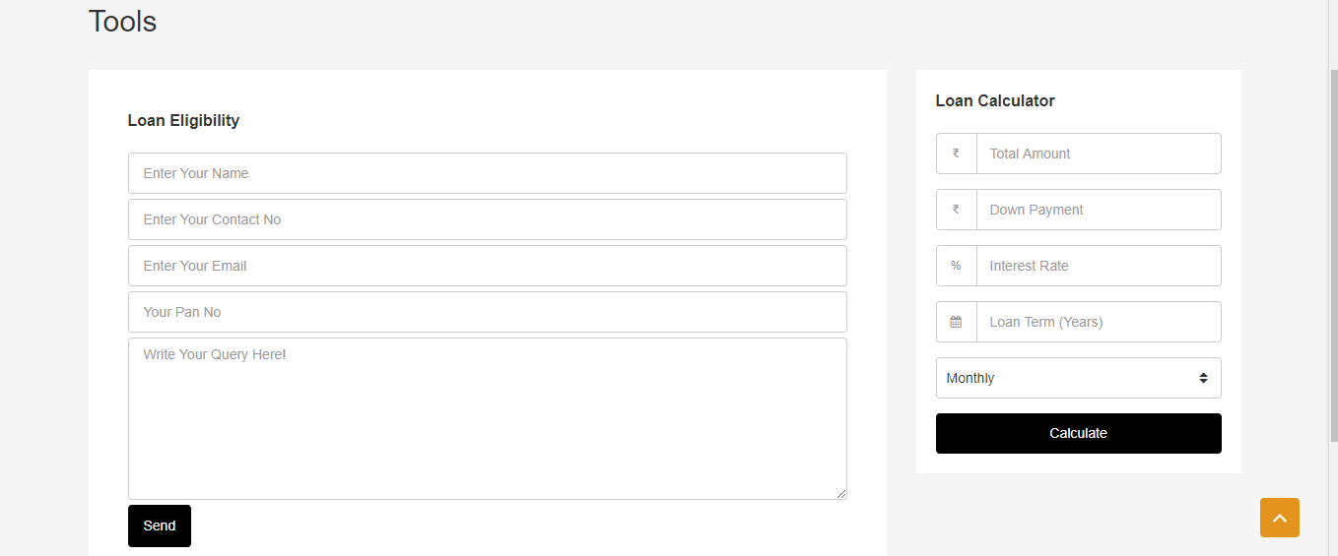

**Our Partners**

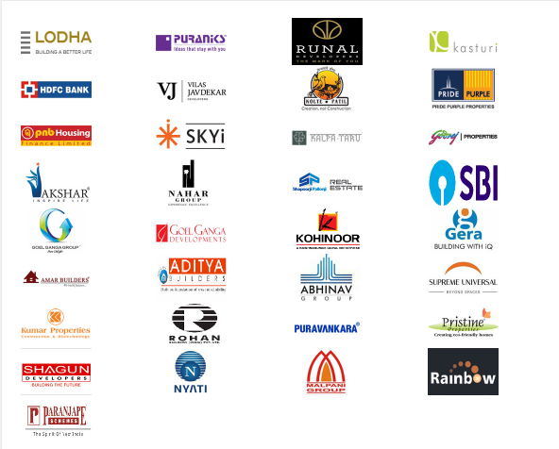

**Our RERA no. A52100018123**